Transforming Ideas about Innovative Products:
BC TEAL UBC
May 5, 2023

Janice GT Penner
pennerj@douglascollege.ca

A WORD doc of this file is provided in the Resources section of
www.AACE-English.com
Permission is granted to copy and use these materials for individual class use. Please uphold Academic Integrity and keep my name on the copy/adapted files.
What to do Doc Page #
- Introduce project.  - In groups, they practice combining ideas and creating new sentences.  - Analyze how the model sentences were done (which grammar strategy was used) | Grammar Review Project plan  Peanut Butter combining task  Suggested Model: P B Production | 3  4 & 5  6
- Put ELLs into Project Teams & Assign topics.  - Individuals: figure out combining and then check with each other & gather images to share with their  - Individuals: Write their own Draft 2 and add intro & conclusion  - Team: Determine key images for the “process”. Share & create Visual doc.  - Individual: Write their own Draft 3 & work on their script | Eco-friendly bio-plastic  Cactus Leather  iPhones  Mango Leather  2020 Olympic Games  Sugar Cane Straws | 7 & 8  9 & 10  11 & 12  13 & 14  15 & 16  17 & 18
Presentation:  - Similar set up to info-gap or round robin  table groups.  - They presented at least 2 times to others. | [A few images to fill the tabloid pages!] | 19 & 20

Other project notes
Proficiency Level: Low Advanced: Douglas ELLA 0240 level (BCCAT III, IELTS 5)
Focus: The content is provided, so the focus is on combining ideas (reading/ grammar)
Class Sessions: 100 minute long
Timing: Midterm or Near the end of the term
This is a REVIEW after instruction of: Use of transitions, noticing Word form, Adverb clauses of time & reason, Adjective clauses, use of conjunctions, noticing & changing word form if necessary
This is not paraphrasing task. They should use the key words and can keep the verbs, etc.
Project Teams: a mixture of weaker and stronger writers works well. They planned and consulted with their team, but ultimately the writing and oral presentation were their own.
Visual doc: I printed this for them, so it was portable. Multiple presentations could be done at the same time if they are in a computer lab.
Evaluation Features:
- Written process:
  - Draft 1 Give completion points because they share their ideas with their team.
  - Draft 2: Just provided error codes. Content: best/ sensible combination of ideas. Checked suitability of hook/ introduction and conclusion.
  - Draft 3 (final): how well they edited with codes, overall accuracy
- Visual doc:
  - Images were appropriate (on topic) & sources provided.
Included Topic & Team names. Accuracy of all headings, etc. No sentences.
- Presentation to small groups.
  - ELL could explain the process without looking at written sentences.
  - Referred to and used images well.
  - Appropriate body language (eye contact, relaxed, pointing to image, etc.)
  - Correct pronunciation of key terms.
  - Overall accuracy and fluency.

Grammar Review Project Plan
©Janice GT Penner
Project Purposes:
- Learn about innovative products and other processes
- Practice all the grammar we studied (especially conjunctions, relative clauses & adverb clauses of time.)
- Present your process to your classmates using a visual prompt (in small groups)

Topics: Bio-plastic Cactus Leather Sugarcane Straws Mango leather 2020 Olympic Gold medals iPhones (unsustainable)
Our project process
When & Where? | Who? | What we’ll be doing
Today | Whole Class | - Complete the process re: Peanut Butter as a model
Hmwk for  Date:_________  Draft 1 | Individual | - Receive a set of sentences about a topic (with a few url links to check)  - Google your topic for images /flow charts. These will help you understand the process. Watch videos if possible.  - Save photos to show your small group. Be sure to have the source url.  - Combine the sentences (similar to the Peanut Butter example)  - You may keep in the numbers to help you discuss ideas with your group.  - Submit this Draft 1 to Blackboard on _____ – 30 minutes before the class, so I can print your draft.
In class  _______ | Project Team | - Meet with others with the same topic (aka your project team)  - Share your sentences and choose the best or create better ones.  - Check with me for pronunciation of key words  Brainstorm ideas for how to introduce & conclude this topic
 | Class discussion
Hmwk for  Draft 2 | Individual | - Complete a 2nd draft of the process (your own doc)  - Decide on a “Warm-up” question to get people’s interest.  - Add an introduction and conclusion (your own ideas)  - Consider where new paragraphs could be. Take out the original #.  - Submit it to BB (Academic format) before class  - This document will be graded for accuracy.
In class  _________ | Project Team | - Share your photos with each other  - Decide on which photos to use to explain the process (the focus)  For the “process” part of the presentation, you should have the same photos. You can add more for your own intro & conclusion
 | Project Team | - Create the visual document (4 pages max)  - Format instructions will be given to you.  Have: Title, all your FIRST names, photos with sources –url  - Each of you: Submit to your BB assignment 30 min before class. I will print them in color for each of you.
Hmwk for  Script & Draft 3 | Individual | - Write a Draft 3 of your process. Correct your errors from my feedback.  - If possible, bring an item to help people understand the process.  - Work on your script for your presentation. Practice it!  Summarize & paraphrase the process (don’t read it line by line)
In class  ______ | Individual to small groups | - At least 2 times each of you will present your process to a small group. The Visual document will be available for you to use.
Peanut Butter Production [sources: JGTP common knowledge & various websites]
- Read the following steps for making peanut butter. Ask about words you don’t know.
Part A: Making Peanut Butter (PB)
¹The farmers pull the whole peanut plant from the ground.
²The farmers live in hot climates.
³The farmers separate the peanuts from the roots.
⁴The farmers put the peanuts into large bags.
⁵The large bags are made of jute or plastic.
⁶The farmers sell the peanuts to a food company.
⁷Large trucks transport the peanuts to a food processing plant.
⁸The food processing plant may be in another country.
⁹If it is, large trucks take the peanuts to the port to be shipped to the other country.
¹⁰If the processing plant is national (in the same country), large trucks transport the peanuts to a railway station or transport them directly to the food processing plant.
¹¹A machine removes the hard shells.
¹²If necessary, another machine removes the red papery shells. (It depends on the kind of PB)
¹³The PB Manager roasts (bakes) the peanuts in a large oven.
¹⁴The large oven is set at 500 degrees F.
¹⁵Roasting improves the taste of the peanuts.
¹⁶A grinding machine grinds the peanuts.
¹⁷The peanuts are now a soft paste.
¹⁸The soft paste is similar to the texture of butter.
¹⁹The PB Manager adds salt and other flavours.
²⁰The salt and flavours improve the taste.
²¹A large conveyor belt moves containers around the “filling” station.
²²The containers could be made of glass, plastic or tin.
²³A labeling machine wraps the label around the container.
²⁴The label has the company name and logo printed on it.
²⁵The label has the ingredients listed on it.
²⁶The label has the expiry date printed on it.
²⁷A robot places the peanut butter containers into packing boxes.
²⁸A clerk does an inventory.
²⁹The inventory is a list of the number of containers and their weight.
³⁰The Shipping Manager sends the boxes of peanut butter to the grocery stores.
³¹The grocery stores had ordered the peanut butter before.

Part B: Paragraph Writing Stages Focus All the grammar we studied this term
- Decide which ideas repeat or can be joined with a Relative clause, fanboys, as an adjective, etc.
- Decide which ideas repeat or could be joined with an Adverb Clause of Time/ Reason, etc.
- Using the information, write paragraphs describing the process in Present Tense
  - Pay attention to changes you need to make in word form, punctuation, etc.
  - Add your own topic sentence & conclusion sentence
  - You can also add a few sentences within the process if you feel it is necessary.
Part C: Debrief with the people at your table (maximum of 3)
- Compare how you decided which ideas/ sentences to combine.
- Compare your paragraph with others
- Then, compare it to the Suggested Model: Peanut Butter Production
that Janice wrote.
Suggested Model: Peanut Butter Production
The numbers are in this version to help you see how the info was combined.
(When you write your Draft 1, you can put the numbers, so you can discuss your ideas with your team.
However, do not put the numbers in Draft 2)

^{B}Hook/ Warm-up Question:

^{B}Topic Sentence:

- Which grammar (strategies) were used to combine the ideas?

¹⁻² Farmers, who live in hot climates, pull the whole peanut plant from the ground.

³⁻⁴⁻⁵ After the farmers separate the peanuts from the roots, they put them into large jute or plastic bags.

^{6-added} The farmer sells the peanuts to a food company which processes the peanuts.

⁷⁻⁸⁻⁹⁻¹⁰ Large trucks transport the peanuts to a local food processing plant, or if the plant is in another country, the peanuts are taken to a port by truck or train.
----------------------------------- new paragraph -----------------------

^{Added} The food processing plant completes the process for making the peanut butter (PB).

¹¹ First, a machine removes the hard shells.

¹² If the peanut butter recipe does not include the red papery shell, a machine will remove it.

¹³⁻¹⁴⁻¹⁵ To improve the taste, the PB Manager roasts the peanuts in a large oven at 500ºF.

¹⁶⁻¹⁷⁻¹⁸ A grinding machine grinds the peanuts into a soft paste, which is similar to butter.
.
¹⁹⁻²⁰ The PB Manager adds salt and other flavours in order to improve the taste.

²¹⁻²² A large conveyor belt moves the glass, plastic or tin containers around the “filling” station.

²³⁻²⁶ Each company uses a labeling machine to wrap the containers with important information which includes the company name, ingredients and expiry date.

²⁷ ⁻²⁹ After a robot places the peanut butter containers into packing boxes, a clerk does an inventory which lists the number of containers and the box’s weight.

^{30-31 &-added} The final step is completed by the Shipping Manager who fills the orders that come from grocery stores.

^{B}Conclusion sentence:

B: What suggestions do you have for the Hook, Topic Sentence and Conclusion sentence?

Eco-friendly bioplastic Team: _____________ & _____________

- Algae grows in freshwater
- Algae grows in salt water.
- The algae is an organism.
- The organism grows very quickly.
- Sunlight helps the algae grow very quickly.
- Large groups of algae plants are called algae blooms.
- The algae blooms take oxygen.
- The oxygen is from the water.
- The algae blooms release harmful toxins.
- The animal life in the water dies.
- The vegetation in the surrounding area dies.
- Some scientists discovered something about algae blooms.
- They discovered algae blooms can be used to clean the environment.
- They discovered they could convert the algae blooms into a bioplastic material.
- The bioplastic is a foam.
- The foam is used in the soles of most shoes.

- An American company developed the technology.
- The company’s name is Algix.
- It took 4 years for Algix to develop the technology.
- The technology is for making the algae bloom into bioplastic.
- They began production in 2010.
- They harvest the algae blooms.
- The algae blooms come from all over the world.
- The algae is squeezed.
- The algae mixture is made into a paste.
- The paste is heated.
- The paste is dried in facilities.
- The algae is now in flakes.
- The facilities are around the world.
- The dried flakes are sent to Algix’s headquarters.
- The headquarters is in Meridian, Mississippi.
- The headquarters has a modern manufacturing facility.
- The facility is 70,000 square feet (size).
- The flakes are pounded into a fine powder.
- A thermoplastic compound is added to the powder.
- The mixture is made into pellets.
- The pellets are ready to be made into foam products.
- They distribute the pellets to more than 200 factories around the world.
- The pellets are used to make shoes, yoga mats, surfboards and other sports and consumer goods.
- The products are considered high-performance (good quality).

- The process of producing the goods does not release toxic compounds.
- The goods are 100% biodegradable.
- This whole process cleans air.
- The process reduces water pollution.
- The algae replaces traditional plastic.
- The traditional plastic is made from petroleum.
- Petroleum is a fossil fuel.
- Fossil fuel is a non-renewable resource.
- Algae is a sustainable resource.
- Using algae in this way is a win-win situation.

Sources:

Grace, B. (2020 October 30). Harvesting algae to produce eco-friendly plastic compounds
https://knowledge.ulprospector.com/11132/harvesting-algae-to-produce-eco-friendly-plastic-compounds/

Phipps, L. (2020 April 7).Algae As a Toxin-Transformer https://www.brinknews.com/algae-is-the-plant-based-nontoxic-alternative-to-plastic-sustainability-environment-climate/

Cactus Leather (aka Nopal leather) Team: _____________ & _____________

- Some people are trying not to use animal leather.
- Leather is used in fashion, automobiles, and furniture.
- Advocates believe it is cruel to kill animals for their skins.
- Animal leather uses a lot of chemicals to produce it.
- Animal leather uses a lot of water to produce it.
- Animal leather production also causes severe water pollution.
- The water pollution results in environmental pollution.
- The water pollution destroys agriculture.
- Indian people live near the tanneries (one step in the process)
- There are many health problems in their children.
- The problems include mental illness, blindness and undeveloped body parts.

- Cactus leather is a new innovation.
- Two Mexican brothers introduced the first leather from cactus plants.
- The two Mexican’s names are Adrian Lopez Velarde and Marte Cazzarez.
- They founded the company.
- Desserto is their company’s name.
- They worked two years to develop the process.
- They patented the process.
- They introduced their cactus leather to a world-wide competition.
- The competition was in 2019.
- The competition was in Munich, Germany.
- The competition had 1,400 innovators from 52 countries.
- They won the 7th International Green Product Award.
- Their product is not “pleather” or “faux leather.”
- Pleather and faux leather are made with PVC plastic.
- PVC (polyvinylchloride) is a by-product of petroleum.

- Cactus leather is a sustainable leather alternative.
- Cactus leather is made from the Opuntia Cactus (also known as Nopal or prickly pear cactus).
- The plant grows in warm dry climates.
- The plant prefers sandy and rocky soil conditions.
- It needs very little water to grow.
- The farmers water the plants during the summer.
- They water the plants every two or three weeks.
- No chemicals are used.
- Their cactus plants are organic.
- They do not use fertilizers.
- They do not use pesticides.
- Expensive irrigation is not needed.
- 1 kg of the dry materials can be produced.
- The 1 kg only needs 200 litres of water to produce it.
- All of the plant is not used.
- Only the mature parts are harvested (top leaves).
- The core of the plant is not harvested.
- The core can grow more leaves in 6 – 8 months.
- A plant can live 10 – 30 years.
- This is a product.
- This makes it sustainable.

- The leaves are picked
- The leaves are washed.
- The leaves are ground into a mush.
- The mush is put in the sun to dry.
- The mush is in the sun for 3 days.
- The dry material is broken down into a powder.
- The proteins are extracted.
- The fibres are extracted.
- The proteins and fibres create a bio-resin.
- The bio-resin helps with the process.
- The process is molecular binding.
- The mixture is mixed with non-toxic chemicals.
- The substance is attached to a backing.
- The leather can be made in different thicknesses.
- The thickness depends on what it is used for.
- The leather can be used for shoes, clothing or purses.
- The leather can be different colors.
- The Desserto company claims the cactus leather is durable.
- The cactus leather has a life span of 10 years.
- Animal leather can last for decades.

Sources:
Desserto (2021). Cactus Vegan Leather. https://desserto.com.mx/home
Oskar. (August 9, 2020). What Is Cactus Leather? Everything You Need to Know. Blackwood. https://goblackwood.co.uk/cactus-leather/
Watson & Wolfe. (n.d.). Vegan Leather made with Cactus Leaves. Watson & Wolfe. https://www.watsonwolfe.com/2020/07/13/vegan-leather-made-with-cactus-leaves/

iPhones Team: _____________ & _____________
(an unsutainable product)
- The iPhone is Apple’s most profitable product
- The iPhone is Apple’s best-selling product.
- More than a billion have been sold since the first one was released.
- The first iPhone was released in 2007.
- The software was developed by American developers.
- The software was developed by industrial designers.
- The developers and industrial designers are in California.
- Apple’s headquarters is in Cupertino, California.
- The IPhones’ brain is the A6 chip.
- The A6 chip is manufactured by a semiconductor company.
- The semiconductor company is in the US.
- Apple orders many of the other components from global suppliers.
- The components come from more than 200 suppliers
- The components include the modem.
- The components include the camera module.
- The components include the microchip.
- The microchip is made by Samsung in Korea.
- Rare earth minerals are used for several parts.
- The rare earth minerals are used for the color screen.
- The rare earth minerals are used for the circuits.
- Ninety percent of the rare earth minerals are mined in Mongolia.
- The gyroscope is used for the tracking orientation.
- The gyroscope was developed in Geneva, Switzerland.

- Apple sells the components to one of its manufacturers based in China.
- The manufacturers have a contract with Apple.
- About half of all iPhones now are made in a huge manufacturing facility.
- The facility is in the central Chinese city of Zhengzhou.
- Foxconn is a company based in Taiwan.
- Foxconn runs the Zhengzhou facility.
- Foxconn’s facilities in Zhengzhou cover 2.2 square miles.
- Foxconn can employ up to 350,000 workers.
- The operation does what is called F.A.T.P..
- .F.A.T.P. stands for final assembly, testing and packaging.
- There are 94 production lines at the Zhengzhou manufacturing site.
- It takes about 400 steps to assemble the iPhone.
- The steps include polishing.
- The steps include soldering.
- The steps include drilling.

- The steps include fitting screws.
- The Foxconn facility can produce 500,000 iPhones a day.
- The facility can produce roughly 350 iPhones a minute.

- The iPhone rolls off the assembly line
- The iPhones are placed in a sleek white fiberboard box.
- The boxes are wrapped and put on a wooden pallet.
- The pallets are taken to waiting trucks.
- The iPhones are transported a few hundred yards beyond the factory gate.
- Beyond the factory gate is a large government building for processing Customs.
- The customs facility is in a so-called bonded zone.
- This zone allows Apple to sell the iPhones more easily to Chinese consumers.
- The iPhones sold in China are typically loaded onto a large truck.
- The tractor-trailer holds up to 36,000 iPhones.
- Those iPhones are worth about $27 million.
- The tractor-trailer is equipped with cameras.
- Sometimes the trucks are accompanied by armed security guards.
- The trucks take an 18-hour drive (590 drive) from Zhengzhou to Shanghai.
- Apple’s national distribution center is in Shanghai.
- It takes about 2 days for an iPhone to get to a Shanghai store from the factory.

- iPhones are also sent around the world.
- Those iPhones leave the Customs building by truck.
- Years ago, the iPhones were sent to the United States by container ship.
- The trip lasted about a month.
- Now, the truck goes to the airport.
- The Zhengzhou airport is three miles from the Foxconn factory.
- A single wide-body Boeing 747 can easily carry 150,000 iPhones
- Usually, it takes three days for an iPhone to get a store in San Francisco.
- The iPhone was in the factory in Zhengzhou.
- San Francisco is about 6,300 miles away from the Zhengzhou.
- The Foxconn factory is in Zhengzhou.

Source: Barboza, D. (n.d.). An iPhone’s Journey, From the Factory Floor to the Retail Store. The New York Times. https://www.nytimes.com/2016/12/29/technology/iphone-china-apple-stores.html

Anthony, James (n.d.) How iPhone Is Made: The Global Assembly Line

https://financesonline.com/hello-world-the-economics-of-iphone/

Mango Leather Team: _____________ & _____________

- Hugo de Boon and Koen Meerkerk started a company called Fruitleather.
- The Dutch company was started in 2015.
- Fruitleather gets the mangoes from Total Exotics.
- Total Exotics is a firm from Holland.
- The Dutch firm imports 6 million kilograms of mangoes each year.
- Total Exotics inspects the imported mangoes
- Every week around 1,500 mangoes do not pass the quality control process.
- These mangoes are used for making mango leather.

- A machine removes the stones from the mangoes
- The machine crushes the fruit into a pulp.
- The mango fruit is boiled.
- When it is boiled the bacteria is eliminated.
- The mixture is pumped through a tube into a large vat (pot).
- They add some additives to the mixture.
- The additives turn the mango pulp into a leather-like material.

- The mixture is ready.
- The mixture is poured into metal trays
- In the trays, the mixture is smoothed out into sheets.
- The sheets are a cream color.
- The sheets are the same thickness.
- The sheets are durable.
- The metal trays go in a hydrator overnight.
- After the hydrator dries the mixture, the colors are very different.
- The difference in color is based on the type of mango they used.
- For example, a Palmer mango will be a more brownish material.
- A Keitt mango will be a more black material.
- The sheets go to a leather finishing facility.
- The sheets are coated in a protective glaze there.
- The sheets are hung on racks to cool and dry completely.
- A machine applies heat and pressure to the sheets.
- The pressure combines the layers of coating.
- The pressure gives it a leather design.
- Each sheet undergoes this process multiple times.
- This process makes the material very durable.

- The mango fruit leather is sold to designers around the world.
- Luxtra is a sustainable product brand.
- Luxtra is based in London.
- Luxtra will launch a range of leather handbags made from mangoes.

Sources:
Enjoli, A. (n.d.). New Designer Vegan Leather Handbags Are Made From Mangoes. Livekindly. https://www.livekindly.co/new-designer-vegan-leather-handbags-are-made-from-mangoes/
Nixdorf, K. & Harger, E. (2021, August 3). How one Dutch company is making vegan leather from mangoes. Business Insider. https://www.businessinsider.com/leather-company-fruitleather-makes-vegan-leather-from-mangoes-netherlands-2021-7

2020 Olympics and sustainability Team: _____________ & _____________

- In 2021, Tokyo hosted the Olympic and Paralympic Games.
- The organizers wanted to use as many recycled products as possible.
- The process began in early 2017
- In early 2017, Japan announced it would collect old electronics.
- They would repurpose the electronics into medals.
- Between 2017 and 2019, the Tokyo 2020 Medal Project organizers collected electronic devices.
- They collected 78,985 tons of electronic devices.
- The metals came from 6.21 million cell phones and other electronic devices.
- The electronic gadgets came from across Japan.
- They found metals in the donated electronic devices.
- The gold, silver, and bronze elements of the devices were obtained through smelting.
- Smelting is a process that involves heating and melting the gadgets to extract base metals.
- From the electronic devices, they extracted 70 pounds of gold.
- From the electronic devices, they extracted 7,700 pounds of silver.
- From the electronic devices, they extracted 4,850 pounds of bronze
- They produced about 5,000 Olympic medals.

- It’s the first time that ordinary citizens were able to be part of the production process.
- Up to 90% of the Japanese cities, towns, and villages participated.
- They set up donation sites.
- Hundreds of thousands of Japanese citizens donated their old electronic devices to the sites.

- The recycled Olympic medals were part of a larger effort to promote environmental sustainability at the Tokyo Games.

- The Tokyo games were supposed to be held in 2020.
- The Covid-19 pandemic forced the games to be postponed.
- The games were held in 2021.
- In 2021, the organizers used the items that had the 2020 logo and branding.
- They didn’t make new 2021 items.
- The Japanese organizers used other recycled materials.
- The other materials were not used to make medals.
- Most famously, the Olympic Village included beds.
- The beds were made from recycled cardboard.
- The podiums were made of recycled plastic.
- The Olympic medal winners stood on the podiums.
- The Olympic torch included aluminium.
- The aluminium was recycled from temporary housing.
- The temporary housing was built after Japan's Fukushima disaster
- The Fukushima nuclear accident was in 2011.
- The Japanese organizers planned to make more sustainability efforts.
- They had a plan to reuse or recycle 65% of waste generated during the event.
- The Japanese were the first to have all the Olympic medals made out of recycled material.
- The concept of using recycled materials for the Olympics is not new.
- The Rio 2016 Olympic Games used recycled materials.
- Sterling silver was used to make gold and silver medals.
- Thirty percent of the sterling silver used to make the medals was recycled.
- The recycled materials came from car parts and mirror surfaces.

References
Hernandez, Daisy. (2021, August 2). Tokyo's Olympic Medals Are Made Entirely From Recycled Gadgets. Popular Mechanics. https://www.popularmechanics.com/technology/gear/a28509493/tokyo-2020-olympic-medals-recycled-gadgets/
Marshall, John (2021, July 27). Tokyo 2020: Olympic medals made from old smartphones, laptops. Deutsche Welle (DW German broadcaster). https://www.dw.com/en/tokyo-2020-olympic-medals-made-from-old-smartphones-laptops/a-58325432
Talia, Lakritz. (2021, July 27). Tokyo's Olympic medals were made from 78,985 tons of recycled electronic devices, including cell phones. Insider. https://www.insider.com/tokyo-olympics-medals-recycled-cell-phones-2021-7
Vidyashree, S. (2021, August 1). Tokyo Olympics Medals Are Made of Recycled Metal Extracted From 6.21 million Cell Phones. Republic World. https://www.republicworld.com/sports-news/other-sports/tokyo-olympics-medals-are-made-of-recycled-metal-extracted-from-6-dot-21-million-cell-phones.html

Sugarcane straws Team: _____________ & _____________

- Historians think the first straws were used from a plant.
- The plant was wheat.
- The wheat was ripe and dry.
- The stem or stalk of the wheat is called a straw.
- That is how the product got its name.
- In the 1960s, plastic was used to make straws.
- Canada will ban 6 plastic items by the end of 2021.
- The six items are single use plastic items.
- Single use plastic items are designed to only be used one time.
- Drinking straws are a single use plastic item.
- About 57 million plastic straws are used in Canada.
- They are used every year.
- The Canadian government wants to ban these six plastic items.
- These items can be replaced with more eco-friendly products.

- A few companies are making eco-friendly products.
- One company in Taiwan makes eco-friendly straws.
- The company started in 2017.
- The company wanted to fight ocean pollution.
- The company’s name is Ju Tian Cleantech
- Sugarcane plants are used to produce sugar and juice.
- Straws are made out of natural sugarcane fibre.
- The fibre is also called bagasse.
- The fibre is the waste.
- The waste is from making sugar and sugarcane juice.
- The fiber is ground into a pulp
- The pulp is dried in the sun.
- The fiber is chopped
- The fiber is shredded
- The fiber is pulverized into a fine powder.
- The waste is combined with another important ingredient.
- Polylactic acid is the other important ingredient.
- Polylactic acid is a bioplastic that is derived from plant starch.
- The polylactic acid binds the ingredients together.
- The ingredients are made into pellets.
- The pellets are made into straws.
- A plastic straw making machine is used.
- The plastic straw making machines can be used for making sugarcane straws.
- Companies that make plastic straws can also make sugarcane straws.

- Sugarcane straws are best used for cold or lukewarm liquids.
- Sugarcane straws should not be used with very hot liquids.
- Sugarcane straws should not be eaten.
- Sugarcane straws have many advantages.
- Sugarcane straws don’t get soggy
- Sugarcane straws do not fall apart in your mouth.
- Their production has a low negative environmental impact.
- Their production has a low carbon footprint.
- Very little energy is consumed to produce the straws.
- Sugarcane straws are biodegradable
- It only takes about 6 months to decompose.
- To decompose, sugarcane straws need moisture and oxygen in the air.
- The JuTian Cleantech company also designs other products.
- The products are biodegradable.
- The products include drinking cups, bowls, plates, spoons and forks.
Sources:
Palmer, M. Producer. (2019 August 16). How a company makes straws out of sugarcane. Business Insider Today. https://www.facebook.com/BusinessInsiderToday/videos/640483373112490/
Fong-l, C. & Chin, J. (2019 July 12). Start-up begins production of drinking straws made of rice hulls and tea leaves. Taipei Times
http://www.taipeitimes.com/News/taiwan/archives/2019/07/12/2003718544?utm_source=twitter.com/wadekwright
Plastic Ethics. (2018 November 11). How to get rid of single use plastic straw, with natural raw materials: sugarcane fiber. Plastic Ethics. https://www.plasticethics.com/home/2018/11/11/how-to-get-rid-of-single-use-plastic-straw

Zimmer, E. (2020, October 7). Plastic bags, straws will be banned in Canada by the end of next year https://dailyhive.com/vancouver/canada-plastic-ban

Examples of Images that your students will find

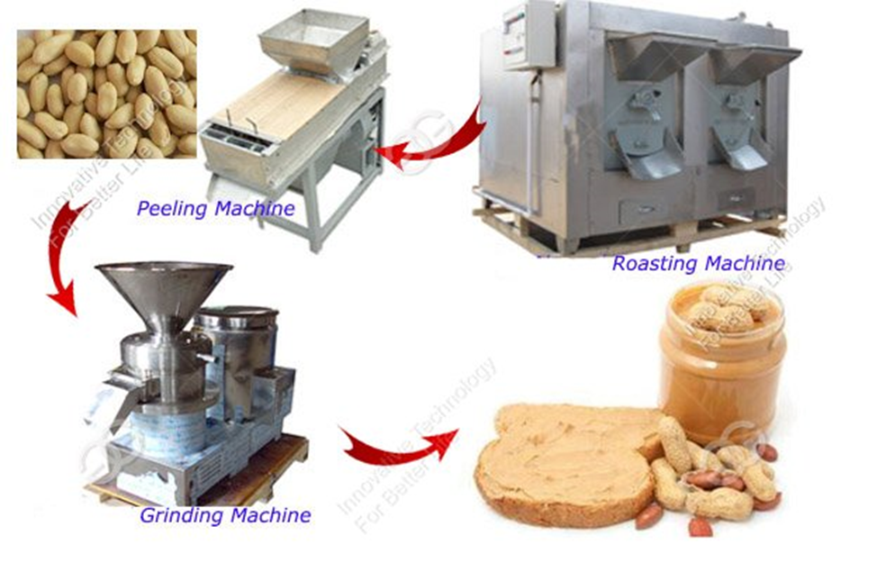

www.gelgoogm.com

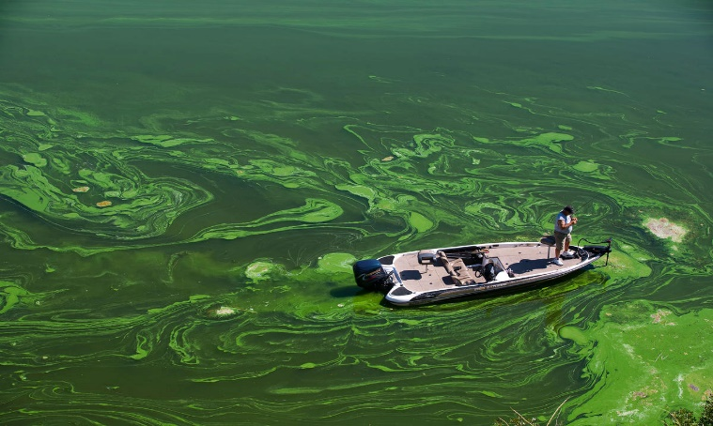
https://www.nrdc.org/stories/freshwater-harmful-algal-blooms-101

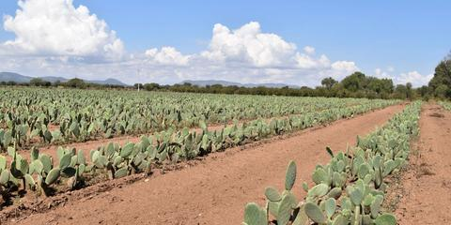

https://www.designboom.com/design/desserto-cactus-vegan-leather

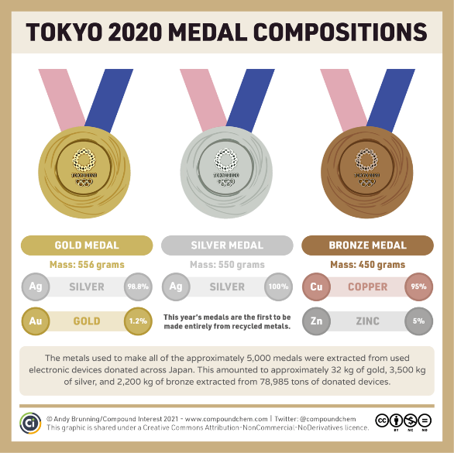
https://www.compoundchem.com/2021/07/27/tokyo2020/

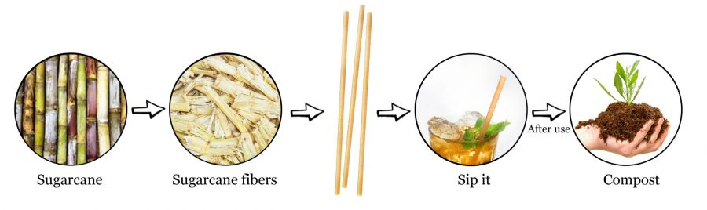

https://www.greencollectivebrand.com/

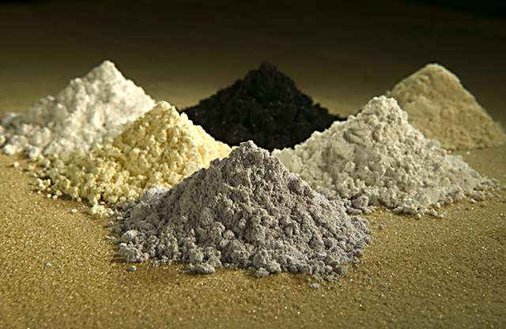
Mined minerals for iPhones: www.financesonline.com

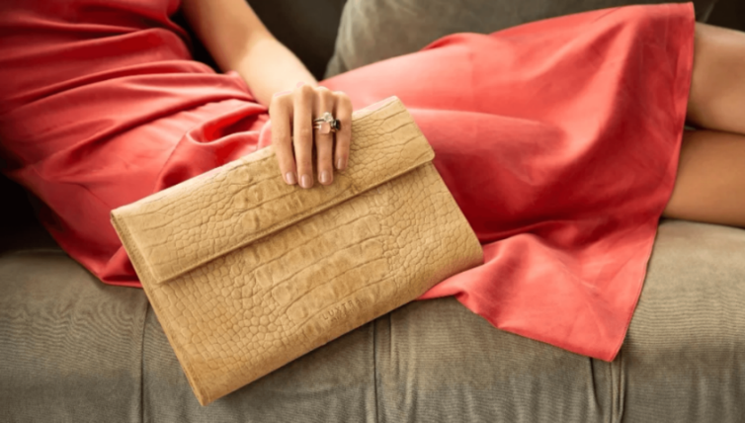
https://www.livekindly.com/new-designer-vegan-leather-handbags-are-made-from-mangoes/

